[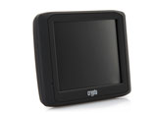](http://www.getitnow.gr/prod/gps/gia-to-aytokinito/crypto-easy-drive-35/prod170385pp/)

[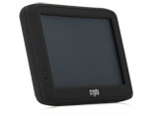](http://www.getitnow.gr/prod/gps/gia-to-aytokinito/crypto-easy-drive-43-/prod170507pp/)